

***Дисциплина: Учебная практика***

**Отчет по выполнению задания на тему: «Lesson 6».**

Выполнил:

Группа: **1ИСП-11-18**

Студент: Белякова Анастасия

Проверил преподаватель:

Мартиросян Ваган Артемович

Москва 2022 г.

Задание 6

create database MebelShop;

go

use MebelShop;

create table staff

(

id int primary key identity,

firtsname nvarchar(50) not null,

lastname nvarchar(50) not null,

number nvarchar(18) unique,

email nvarchar(50) unique,

gender nvarchar(1) check (gender in ('М', 'Ж')),

post nvarchar(50) not null,

salary int not null,

age int

constraint DF_staff_age default 18

constraint CK_staff_age check (Age > 0 and Age < 100)

);

insert into staff(firtsname, lastname, number, email, gender, post, salary, age) values

('Дмитрий', 'Серегин', '89775241258', 'seregindm@ya.ru', 'М', 'Продавец', 45000, 25),

('Роман', 'Мартынов', '89161253698', 'romka@ya.ru', 'М', 'Продавец-консультант', 45000, 23),

('Иван', 'Мухин', '89770256398', 'vanyamuhin@ya.ru', 'М', 'Бухгалтер', 100000, 47),

('Виктория', 'Михайлова', '89784526398', 'mihailovaaaa@ya.ru', 'Ж', 'Администратор', 70000, 32),

('Михаил', 'Максимов', '89142503607', 'maksmiha@ya.ru', 'М', 'Уборщик', 30000, 40),

('Ярослав', 'Алешин', '89178965741', 'yarik@ya.ru', 'М', 'Продавец', 45000, 28),

('Егор', 'Петров', '89770321478', 'egorka22@ya.ru', 'М', 'Менеджер', 50000, 30),

('Надежда', 'Никонова', '89159635800', 'nadezdaddd@ya.ru', 'Ж', 'Кадровик', 25000, 36),

('Алексей', 'Алексеев', '89253698574', 'lehasuper15@ya.ru', 'М', 'Диспетчер', 30000, 21),

('Ирина', 'Сметанина', '89302587412', 'smetana@bk.ru', 'Ж', 'Диспетчер', 30000, default);

create table customer

(

id int primary key identity,

firtsname nvarchar(50) not null,

lastname nvarchar(50) not null,

number nvarchar(18) unique,

email nvarchar(50) unique,

gender nvarchar(1) check (gender in ('М', 'Ж')),

adress nvarchar(90) not null,

age int

constraint DF_customer_age default 18

);

insert into customer(firtsname, lastname, number, email, gender, adress, age) values

('Мария', 'Иванова', '89162589632', 'mariaa31@mail.ru', 'Ж', 'ул. Куйбышева, 31', default),

('Анастасия', 'Павлова', '89142563985', 'nastyaya@mail.ru', 'Ж', 'ул. Сирени, 45', 25),

('Лев', 'Пономарев', '89778576523', 'levpon5@mail.ru', 'М', 'ул. Малая Бронная, 70', 30),

('Варвара', 'Соловьева', '89245632574', 'varya@mail.ru', 'Ж', 'Каширское шоссе, 43', 75),

('Василий', 'Головин', '89289632587', 'vasilyaaa@mail.ru', 'М', 'ул. Маршала Зуева, 12', 63),

('Арсений', 'Родионов', '89175236982', 'arsik@mail.ru', 'М', 'ул. Проводников, 21', 28),

('Василиса', 'Фролова', '89120123680', 'frolova45@mail.ru', 'Ж', 'ул. Лисенко, 32', 34),

('Максим', 'Куликов', '89162574156', 'kulik789@mail.ru', 'М', 'ул. Подводников, 23', 19),

('Артем', 'Балашев', '89779632541', 'artemka12@mail.ru', 'М', 'ул. Шарикоподшипниковская, 3', 20),

('Иван', 'Петров', '89151258745', 'ivan@gamail.com', 'М', 'ул. Ромашки, 56', default);

create table product

(

id int primary key identity(1, 1),

art int unique,

manufacturer nvarchar(100),

productname nvarchar(100) not null,

cost int check (cost > 0) not null,

description_ nvarchar(100) not null,

characteristic_1 nvarchar(50),

characteristic_2 nvarchar(50),

characteristic_3 nvarchar(50),

characteristic_4 nvarchar(50)

);

insert into product(art, manufacturer, productname, cost, description_, characteristic_1, characteristic_2, characteristic_3, characteristic_4) values

(365228, 'Производитель 1', 'Товар 1', 84999, 'Описание', 'Характеристика 1', 'Характеристика 2', 'Характеристика 3', 'Характеристика 4'),

(214785, 'Производитель 2', 'Товар 2', 8999, 'Описание', 'Характеристика 1', 'Характеристика 2', 'Характеристика 3', 'Характеристика 4'),

(021587, 'Производитель 3', 'Товар 3', 31999, 'Описание', 'Характеристика 1', 'Характеристика 2', 'Характеристика 3', 'Характеристика 4'),

(325698, 'Производитель 4', 'Товар 4', 74999, 'Описание', 'Характеристика 1', 'Характеристика 2', 'Характеристика 3', 'Характеристика 4'),

(857496, 'Производитель 1', 'Товар 5', 53999, 'Описание', 'Характеристика 1', 'Характеристика 2', 'Характеристика 3', 'Характеристика 4'),

(032569, 'Производитель 3', 'Товар 6', 42999, 'Описание', 'Характеристика 1', 'Характеристика 2', 'Характеристика 3', 'Характеристика 4'),

(745893, 'Производитель 4', 'Товар 7', 30999, 'Описание', 'Характеристика 1', 'Характеристика 2', 'Характеристика 3', 'Характеристика 4'),

(523698, 'Производитель 5', 'Товар 8', 19999, 'Описание', 'Характеристика 1', 'Характеристика 2', 'Характеристика 3', 'Характеристика 4'),

(452178, 'Производитель 6', 'Товар 9', 10999, 'Описание', 'Характеристика 1', 'Характеристика 2', 'Характеристика 3', 'Характеристика 4'),

(951753, 'Производитель 1', 'Товар 10', 16999, 'Описание', 'Характеристика 1', 'Характеристика 2', 'Характеристика 3', 'Характеристика 4');

create table cart

(

order_code int primary key identity(1, 1),

customerID int references customer (id),

productname nvarchar(100),

type_of_promotion nvarchar(50) check (type_of_promotion in ('Обычная', 'Привилегированная')),

registration_date date not null,

cost_of_order int check (cost_of_order > 0) not null,

sale int,

itog int

);

insert into cart(customerID, productname, type_of_promotion, registration_date, cost_of_order, sale, itog) values

(1, 'Товар 1', 'Привилегированная', '2018-06-03', 84999, 8000, 76999),

(2, 'Товар 2', 'Обычная', '2018-03-07', 8999, 1000, 7999),

(3, 'Товар 3', 'Привилегированная', '2018-05-08', 31999, 5000, 26999),

(4, 'Товар 4', 'Привилегированная', '2018-07-12', 74999, 10000, 64999),

(5, 'Товар 5', 'Привилегированная', '2018-06-24', 53999, 7000, 46999),

(6, 'Товар 6', 'Обычная', '2018-01-09', 42999, 2000, 40999),

(7, 'Товар 7', 'Привилегированная', '2018-12-10', 30999, 3000, 27999),

(8, 'Товар 8', 'Обычная', '2018-09-29', 19999, 1000, 18999),

(9, 'Товар 9', 'Обычная', '2018-03-16', 10999, 1000, 9999),

(10, 'Товар 10,', 'Обычная', '2018-05-14', 16999, 2500, 14499);

select * from staff;

select * from customer;

select * from product;

select * from cart;

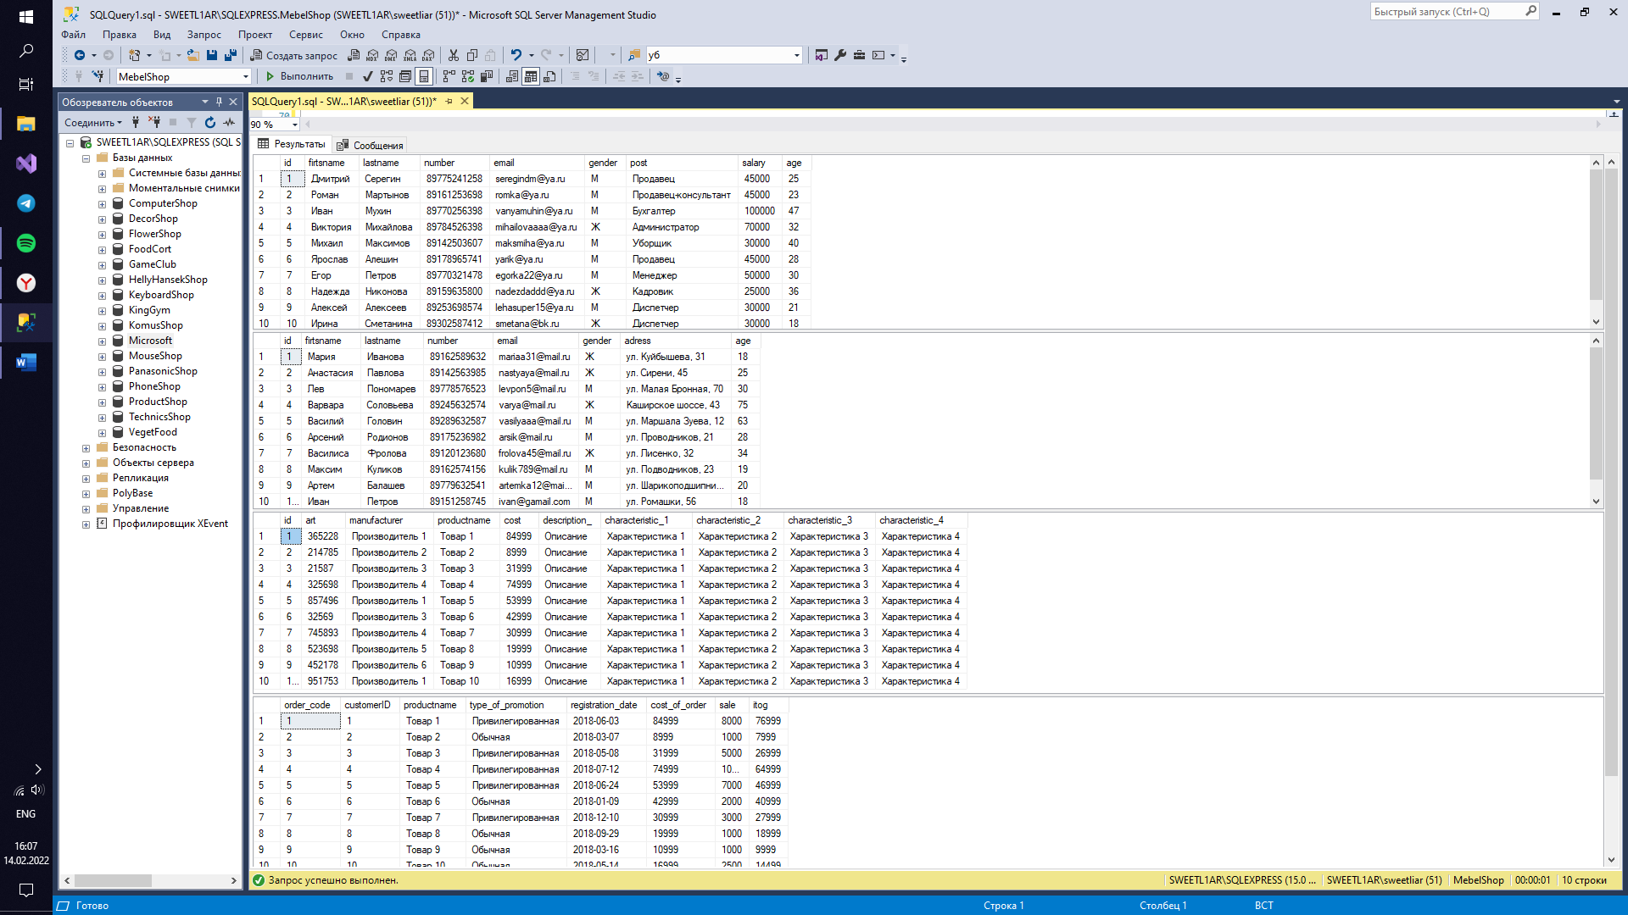

use MebelShop;

update staff set salary = salary + 5000 where age > 30;

delete product where manufacturer = 'Производитель 1';

select * from staff;

select * from customer;

select * from product;

select * from cart;

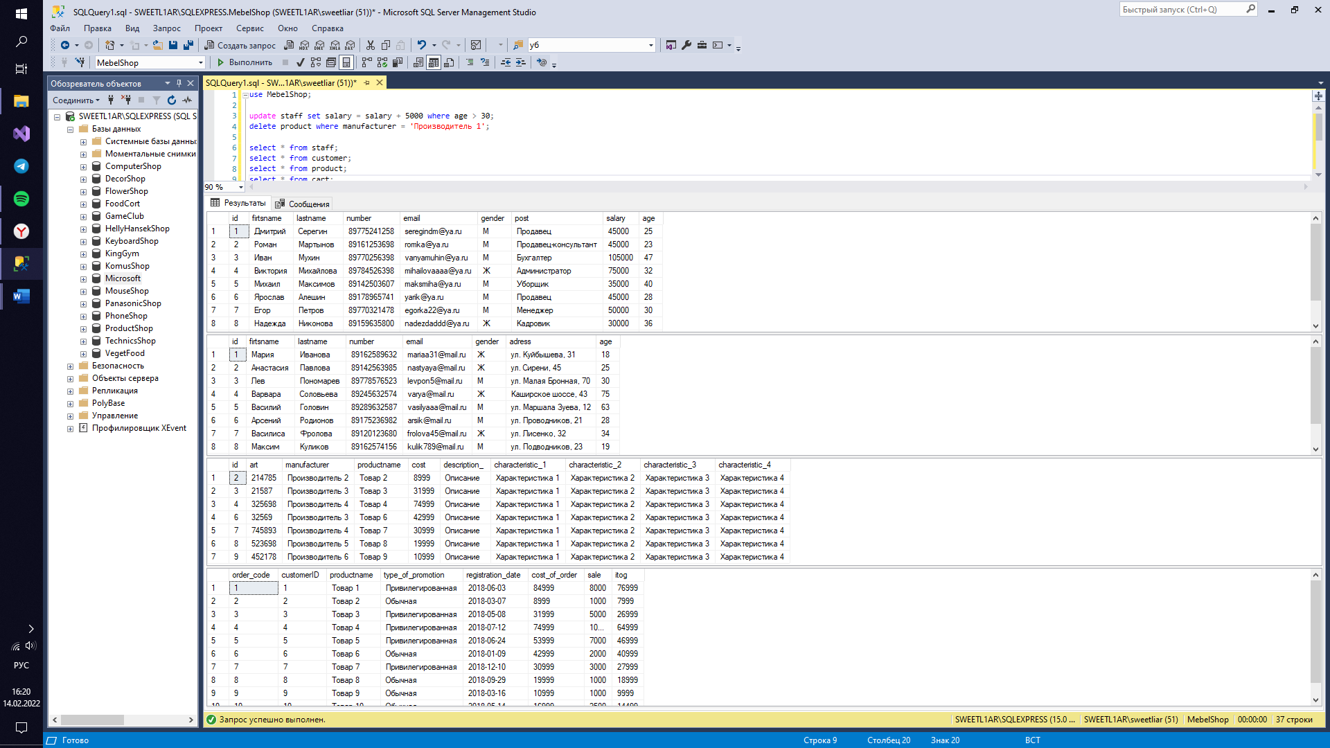

use MebelShop;

select * from staff order by age;

select age from customer where age > 30;

select number from staff;

select productname from cart where sale > 5000;

select firtsname, lastname, email from staff where post = 'Продавец' and age = 25;

select * from product where manufacturer = 'Производитель 4' or cost > 50000;

select * from cart order by itog;

select art from product;

select age from staff where gender = 'Ж';

select firtsname, lastname from customer where age = 18;

select * from staff where age between 18 and 30;

select * from product where cost between 20000 and 50000;

select * from customer where age between 20 and 50;

select id from customer where age in (18, 20, 22, 24, 26, 28, 30);

select id, art, cost from product where manufacturer in ('Производитель 4', 'Производитель 2');

select * from customer where email in ('mariaa31@mail.ru', 'varya@mail.ru', 'arsik@mail.ru');

select manufacturer, count(*) as quantity from product group by manufacturer;

select age, count(*) as quantity from customer where age > 25 and age < 60 group by age;

select manufacturer, count(*) as quantity from product group by manufacturer having count(*) > 0;

select avg(age) as age_avg from staff;

select avg(cost) as avg_cost from product where manufacturer = 'Производитель 3';

select avg(itog) as avg_itog from cart where cost_of_order > 50000;

select count(age) as count_age from customer;

select count(*) as count_ from cart;

select count(cost) as count_cost from product;

select min(age) as min_age from staff;

select min(itog) as min_itog from cart;

select min(sale) as min_sale from cart;

select max(age) as max_age from customer;

select max(itog) as max_itog from cart;

select max(cost) as max_cost from product;

select sum(cost) as sum_cost from product;

select sum(age) as age_sum from customer;

select sum(distinct sale) as sum_sale from cart;

select * from staff;

select * from customer;

select * from product;

select * from cart;

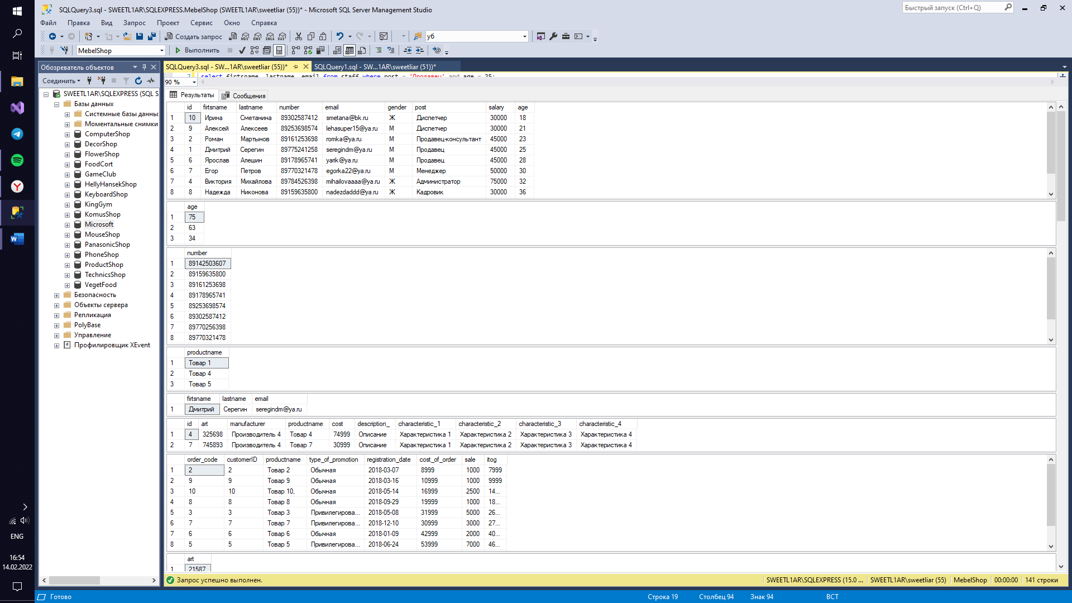

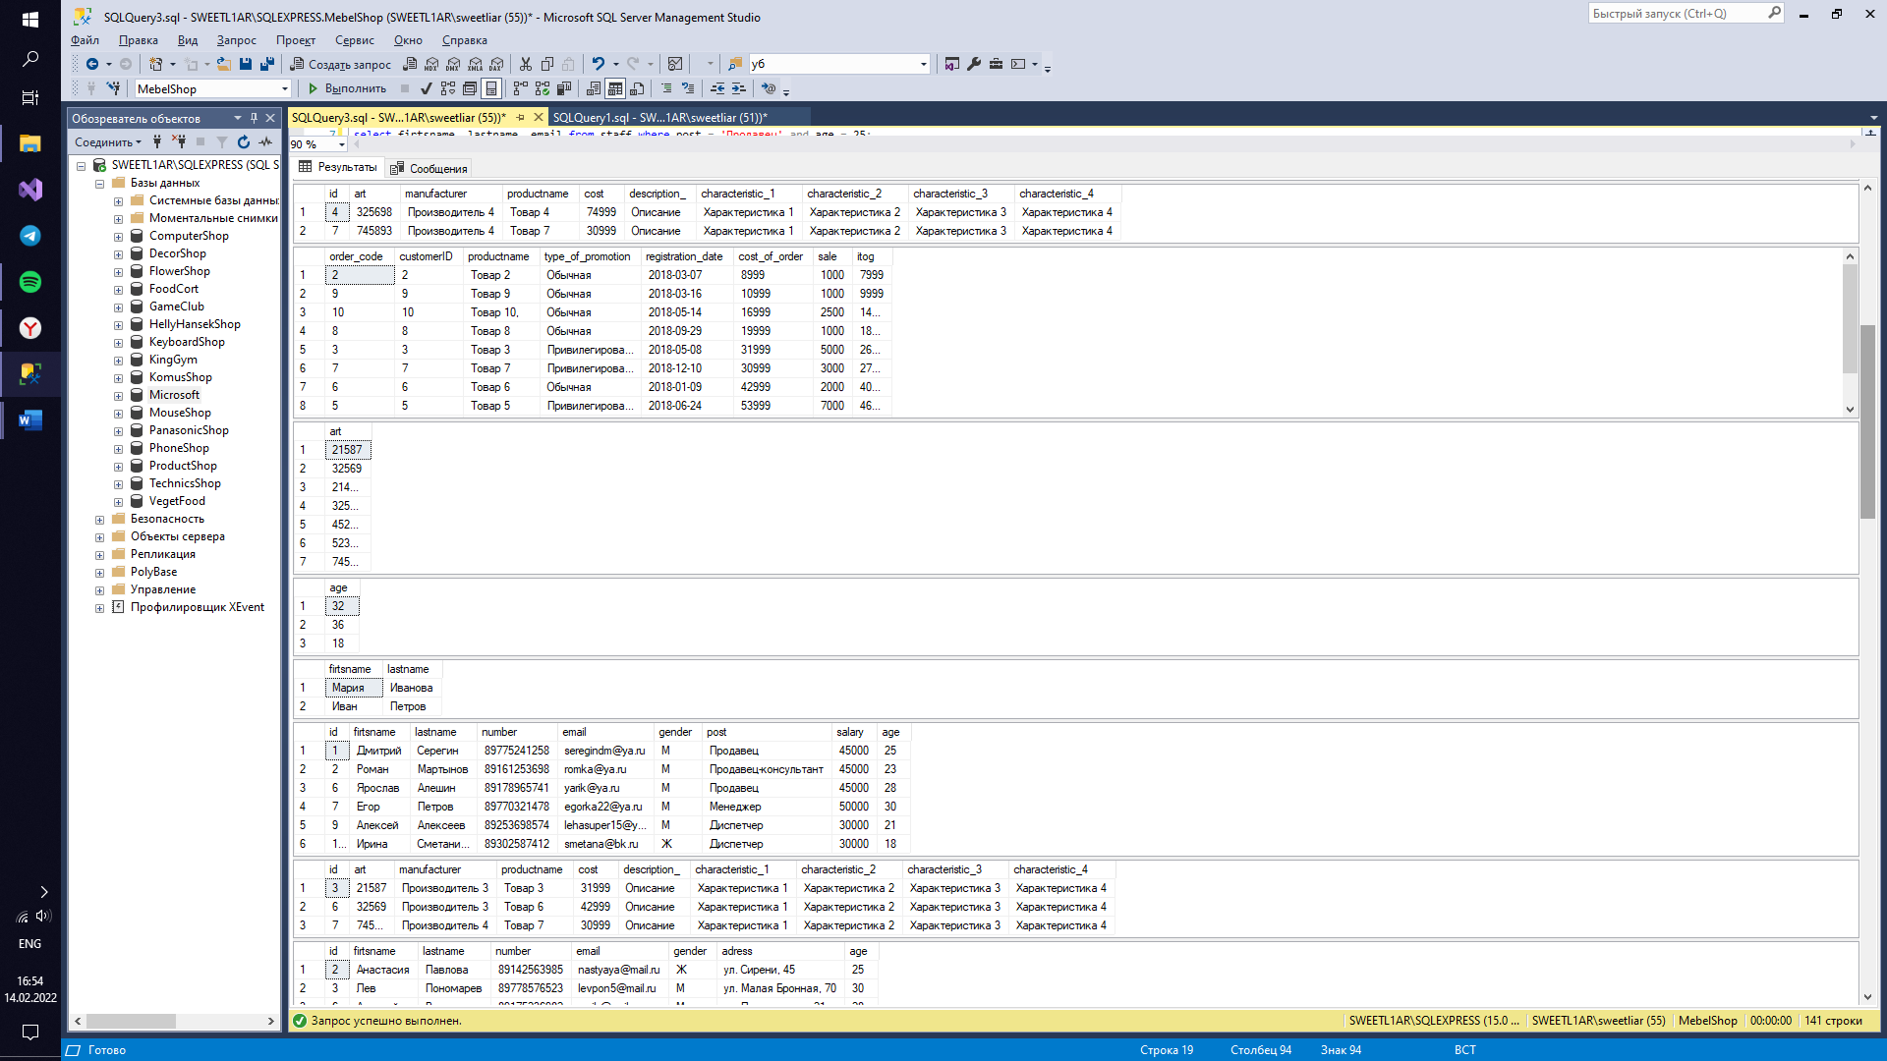

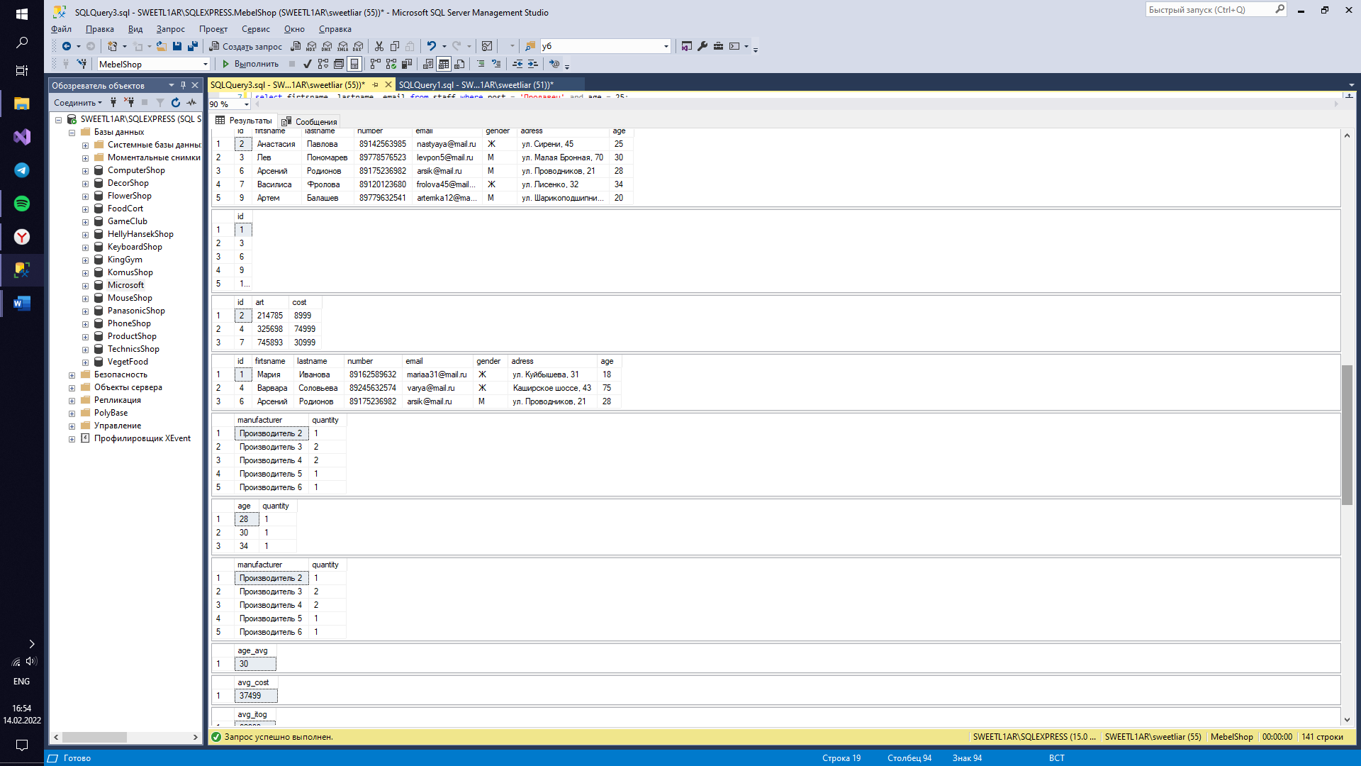

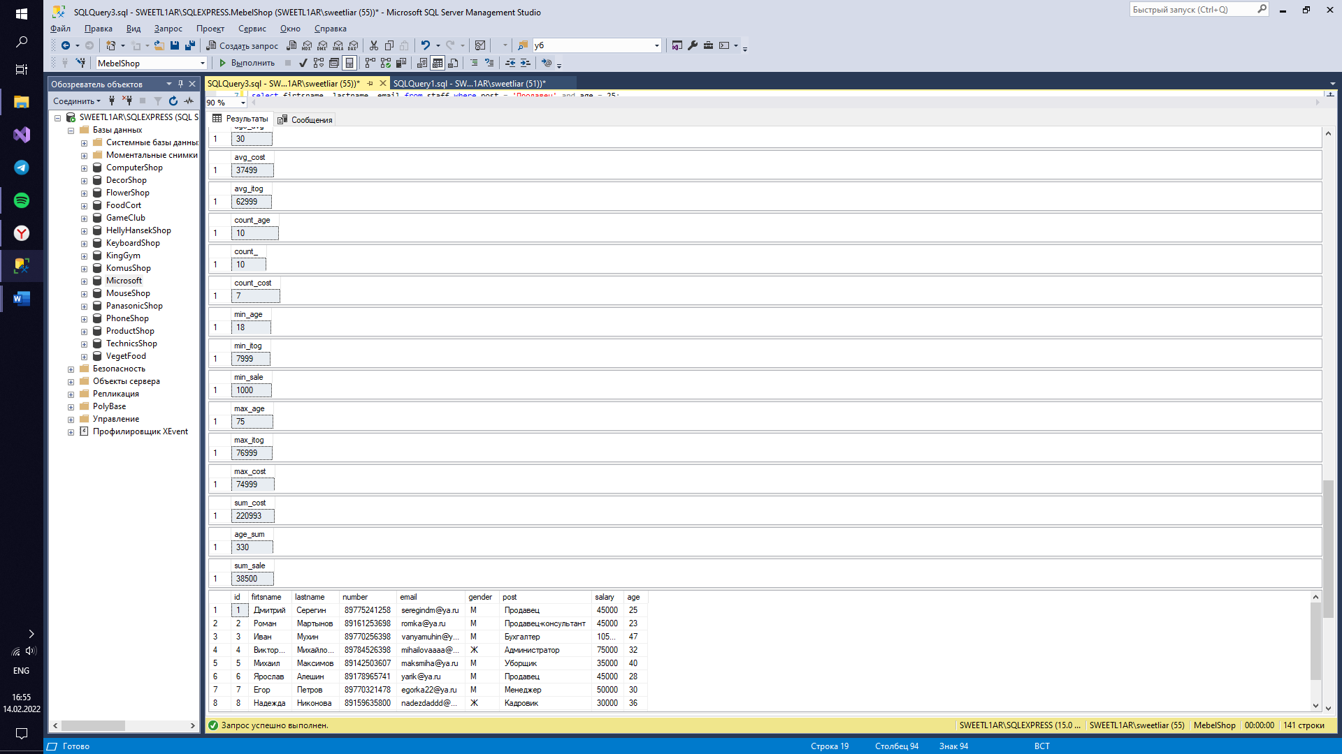

Задание 6.1

create database FiitCrisp;

go

use FiitCrisp;

create table staff

(

id int primary key identity,

firtsname nvarchar(50) not null,

lastname nvarchar(50) not null,

number nvarchar(18) unique,

email nvarchar(50) unique,

gender nvarchar(1) check (gender in ('М', 'Ж')),

post nvarchar(50) not null,

salary int not null,

age int

constraint DF_staff_age default 18

constraint CK_staff_age check (Age > 0 and Age < 100)

);

insert into staff(firtsname, lastname, number, email, gender, post, salary, age) values

('Дмитрий', 'Серегин', '89775241258', 'seregindm@ya.ru', 'М', 'Продавец', 45000, 25),

('Роман', 'Мартынов', '89161253698', 'romka@ya.ru', 'М', 'Продавец-консультант', 45000, 23),

('Иван', 'Мухин', '89770256398', 'vanyamuhin@ya.ru', 'М', 'Бухгалтер', 100000, 47),

('Виктория', 'Михайлова', '89784526398', 'mihailovaaaa@ya.ru', 'Ж', 'Администратор', 70000, 32),

('Михаил', 'Максимов', '89142503607', 'maksmiha@ya.ru', 'М', 'Уборщик', 30000, 40),

('Ярослав', 'Алешин', '89178965741', 'yarik@ya.ru', 'М', 'Продавец', 45000, 28),

('Егор', 'Петров', '89770321478', 'egorka22@ya.ru', 'М', 'Менеджер', 50000, 30),

('Надежда', 'Никонова', '89159635800', 'nadezdaddd@ya.ru', 'Ж', 'Кадровик', 25000, 36),

('Алексей', 'Алексеев', '89253698574', 'lehasuper15@ya.ru', 'М', 'Диспетчер', 30000, 21),

('Ирина', 'Сметанина', '89302587412', 'smetana@bk.ru', 'Ж', 'Диспетчер', 30000, default);

create table customer

(

id int primary key identity,

firtsname nvarchar(50) not null,

lastname nvarchar(50) not null,

number nvarchar(18) unique,

email nvarchar(50) unique,

gender nvarchar(1) check (gender in ('М', 'Ж')),

adress nvarchar(90) not null,

age int

constraint DF_customer_age default 18

);

insert into customer(firtsname, lastname, number, email, gender, adress, age) values

('Мария', 'Иванова', '89162589632', 'mariaa31@mail.ru', 'Ж', 'ул. Куйбышева, 31', default),

('Анастасия', 'Павлова', '89142563985', 'nastyaya@mail.ru', 'Ж', 'ул. Сирени, 45', 25),

('Лев', 'Пономарев', '89778576523', 'levpon5@mail.ru', 'М', 'ул. Малая Бронная, 70', 30),

('Варвара', 'Соловьева', '89245632574', 'varya@mail.ru', 'Ж', 'Каширское шоссе, 43', 75),

('Василий', 'Головин', '89289632587', 'vasilyaaa@mail.ru', 'М', 'ул. Маршала Зуева, 12', 63),

('Арсений', 'Родионов', '89175236982', 'arsik@mail.ru', 'М', 'ул. Проводников, 21', 28),

('Василиса', 'Фролова', '89120123680', 'frolova45@mail.ru', 'Ж', 'ул. Лисенко, 32', 34),

('Максим', 'Куликов', '89162574156', 'kulik789@mail.ru', 'М', 'ул. Подводников, 23', 19),

('Артем', 'Балашев', '89779632541', 'artemka12@mail.ru', 'М', 'ул. Шарикоподшипниковская, 3', 20),

('Иван', 'Петров', '89151258745', 'ivan@gamail.com', 'М', 'ул. Ромашки, 56', default);

create table product

(

id int primary key identity(1, 1),

art int unique,

manufacturer nvarchar(100),

productname nvarchar(100) not null,

cost int check (cost > 0) not null,

description_ nvarchar(100) not null,

characteristic_1 nvarchar(50),

characteristic_2 nvarchar(50),

characteristic_3 nvarchar(50),

characteristic_4 nvarchar(50)

);

insert into product(art, manufacturer, productname, cost, description_, characteristic_1, characteristic_2, characteristic_3, characteristic_4) values

(365228, 'Производитель 1', 'Товар 1', 84999, 'Описание', 'Характеристика 1', 'Характеристика 2', 'Характеристика 3', 'Характеристика 4'),

(214785, 'Производитель 2', 'Товар 2', 8999, 'Описание', 'Характеристика 1', 'Характеристика 2', 'Характеристика 3', 'Характеристика 4'),

(021587, 'Производитель 3', 'Товар 3', 31999, 'Описание', 'Характеристика 1', 'Характеристика 2', 'Характеристика 3', 'Характеристика 4'),

(325698, 'Производитель 4', 'Товар 4', 74999, 'Описание', 'Характеристика 1', 'Характеристика 2', 'Характеристика 3', 'Характеристика 4'),

(857496, 'Производитель 1', 'Товар 5', 53999, 'Описание', 'Характеристика 1', 'Характеристика 2', 'Характеристика 3', 'Характеристика 4'),

(032569, 'Производитель 3', 'Товар 6', 42999, 'Описание', 'Характеристика 1', 'Характеристика 2', 'Характеристика 3', 'Характеристика 4'),

(745893, 'Производитель 4', 'Товар 7', 30999, 'Описание', 'Характеристика 1', 'Характеристика 2', 'Характеристика 3', 'Характеристика 4'),

(523698, 'Производитель 5', 'Товар 8', 19999, 'Описание', 'Характеристика 1', 'Характеристика 2', 'Характеристика 3', 'Характеристика 4'),

(452178, 'Производитель 6', 'Товар 9', 10999, 'Описание', 'Характеристика 1', 'Характеристика 2', 'Характеристика 3', 'Характеристика 4'),

(951753, 'Производитель 1', 'Товар 10', 16999, 'Описание', 'Характеристика 1', 'Характеристика 2', 'Характеристика 3', 'Характеристика 4');

create table cart

(

order_code int primary key identity(1, 1),

customerID int references customer (id),

productname nvarchar(100),

type_of_promotion nvarchar(50) check (type_of_promotion in ('Обычная', 'Привилегированная')),

registration_date date not null,

cost_of_order int check (cost_of_order > 0) not null,

sale int,

itog int

);

insert into cart(customerID, productname, type_of_promotion, registration_date, cost_of_order, sale, itog) values

(1, 'Товар 1', 'Привилегированная', '2018-06-03', 84999, 8000, 76999),

(2, 'Товар 2', 'Обычная', '2018-03-07', 8999, 1000, 7999),

(3, 'Товар 3', 'Привилегированная', '2018-05-08', 31999, 5000, 26999),

(4, 'Товар 4', 'Привилегированная', '2018-07-12', 74999, 10000, 64999),

(5, 'Товар 5', 'Привилегированная', '2018-06-24', 53999, 7000, 46999),

(6, 'Товар 6', 'Обычная', '2018-01-09', 42999, 2000, 40999),

(7, 'Товар 7', 'Привилегированная', '2018-12-10', 30999, 3000, 27999),

(8, 'Товар 8', 'Обычная', '2018-09-29', 19999, 1000, 18999),

(9, 'Товар 9', 'Обычная', '2018-03-16', 10999, 1000, 9999),

(10, 'Товар 10,', 'Обычная', '2018-05-14', 16999, 2500, 14499);

create table orders

(

id int primary key identity,

orderID int references cart (order_code),

productname nvarchar(200),

delivery_or_pickup nvarchar(70) check (delivery_or_pickup in ('Самовывоз', 'Доставка'))not null,

cost_of_order int check (cost_of_order > 0) not null,

sale int,

itog int,

quantity int check (quantity > 0),

registration_date date not null,

);

insert into orders(orderID, productname, delivery_or_pickup, cost_of_order, sale, itog, quantity, registration_date) values

(1, 'Товар 1', 'Самовывоз', 84999, 8000, 76999, 1, '2018-06-03'),

(2, 'Товар 2', 'Доставка', 8999, 1000, 7999, 1, '2018-03-07'),

(3, 'Товар 3', 'Самовывоз', 31999, 5000, 26999, 1, '2018-05-08'),

(4, 'Товар 4', 'Самовывоз', 74999, 10000, 64999, 1, '2018-07-12'),

(5, 'Товар 5', 'Доставка', 53999, 7000, 46999, 1, '2018-06-24'),

(6, 'Товар 6', 'Самовывоз', 42999, 2000, 40999, 1, '2018-01-09'),

(7, 'Товар 7', 'Доставка', 30999, 3000, 27999, 1, '2018-12-10'),

(8, 'Товар 8', 'Доставка', 19999, 1000, 18999, 1, '2018-09-29'),

(9, 'Товар 9', 'Самовывоз', 10999, 0, 10999, 1, '2018-03-16'),

(10, 'Товар 10', 'Доставка', 16999, 2500, 14499, 1, '2018-05-14');

create table stock

(

id int primary key identity,

name_of_the_promotion nvarchar(50),

product nvarchar(50),

price_without_promotion int,

price_with_stock int,

discount int,

start_data date,

end_data date,

type_of_promotion nvarchar(50) check (type_of_promotion in ('Обычная', 'Привилегированная'))

);

insert into stock(name_of_the_promotion, product, price_without_promotion, discount, price_with_stock, start_data, end_data, type_of_promotion) values

('Акция 1', 'Товар 1', 84999, 8000, 76999, '2018-05-10', '2018-10-10', 'Привилегированная'),

('Акция 2', 'Товар 2', 8999, 1000, 7999, '2018-05-10', '2018-10-10', 'Обычная'),

('Акция 3', 'Товар 3', 31999, 5000, 26999, '2018-05-10', '2018-10-10', 'Привилегированная'),

('Акция 4', 'Товар 4', 74999, 10000, 64999, '2018-05-10', '2018-10-10', 'Привилегированная'),

('Акция 5', 'Товар 5', 53999, 7000, 46999, '2018-05-10', '2018-10-10', 'Привилегированная'),

('Акция 6', 'Товар 6', 42999, 2000, 40999, '2018-05-10', '2018-10-10', 'Обычная'),

('Акция 7', 'Товар 7', 30999, 3000, 27999, '2018-05-10', '2018-10-10', 'Привилегированная'),

('Акция 8', 'Товар 8', 19999, 1000, 18999, '2018-05-10', '2018-10-10', 'Обычная'),

('Акция 9', 'Товар 9', 10999, 1000, 9999, '2018-05-10', '2018-10-10', 'Обычная'),

('Акция 10', 'Товар 10', 16999, 2500, 14499, '2018-05-10', '2018-10-10', 'Обычная');

select * from staff;

select * from customer;

select * from product;

select * from cart;

select * from stock;

select * from orders;

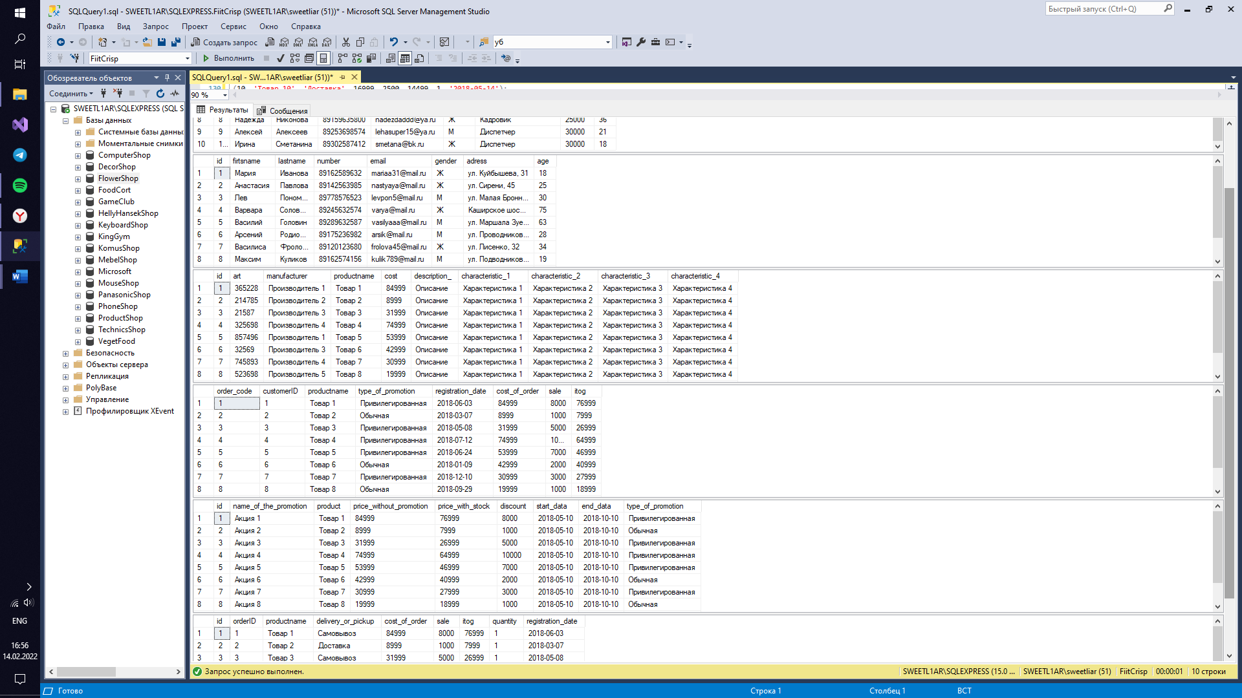

use FiitCrisp;

update staff set age = age + 2 where age > 20;

delete product where manufacturer = 'Производитель 6';

select * from staff order by age;

select age from customer where age > 30;

select number from staff;

select productname from cart where sale > 5000;

select firtsname, lastname, email from staff where post = 'Продавец' and age > 20;

select * from product where manufacturer = 'Производитель 3' or cost < 70000;

select * from cart order by sale;

select art, cost from product order by art;

select age from staff where gender = 'М';

select firtsname, lastname from customer where age = 18;

select name_of_the_promotion from stock where type_of_promotion = 'Обычная';

select * from orders where delivery_or_pickup = 'Доставка' and cost_of_order > 20000;

select id from stock where discount = 10000;

select * from orders order by registration_date;

select productname from cart order by registration_date;

select * from staff where age between 18 and 30;

select * from product where cost between 20000 and 50000;

select * from customer where age between 20 and 50;

select productname from orders where sale between 1000 and 5000;

select * from orders where cost_of_order between 20000 and 70000;

select * from stock where discount between 0 and 35000;

select id from customer where age in (18, 20, 22, 24, 26, 28, 30);

select id, art, cost from product where manufacturer in ('Производитель 4', 'Производитель 2');

select * from customer where email in ('mariaa31@mail.ru', 'varya@mail.ru', 'arsik@mail.ru');

select * from orders where sale in (2000, 3000, 5000, 7000);

select * from stock where name_of_the_promotion in ('Акция 2', 'Акция 7', 'Акция 9');

select order_code from cart where itog in (76999, 7999, 27999);

select avg(age) as age_avg from customer;

select avg(cost) as avg_cost from product where manufacturer = 'Производитель 1';

select avg(itog) as avg_itog from cart where cost_of_order > 20000;

select avg(sale) as avg_sale from orders;

select avg(discount) as avg_disc from stock;

select avg(cost_of_order) as avg_coo from cart;

select count(age) as count_age from customer;

select count(*) as count_ from cart;

select count(cost) as count_cost from product;

select count(itog) as count_itog from cart;

select count(*) as count_sale from cart;

select count(*) as count_all from orders;

select min(age) as min_age from customer;

select min(itog) as min_itog from cart;

select min(sale) as min_sale from cart;

select min(cost_of_order) as min_coo from orders;

select min(distinct age) as min_age_staff from staff;

select min(registration_date) as min_regdate from orders;

select max(age) as max_age from staff;

select max(itog) as max_itog from cart;

select max(distinct cost) as max_cost from product;

select max(registration_date) as max_regdate from orders;

select max(age) as max_age_cust from customer;

select max(sale) as max_sale from cart;

select sum(cost) as sum_cost from product;

select sum(age) as age_sum from customer;

select sum(distinct sale) as sum_sale from cart;

select sum(age) as sum_age_staff from staff;

select sum(itog) as sum_itog from orders;

select sum(price_with_stock) as sum_pws from stock;

select manufacturer, count(*) as quantity from product group by manufacturer order by quantity desc;

select age, count(*) as quantity from customer where age > 18 and age < 50 group by age;

select type_of_promotion, count(*) as quantity from cart group by type_of_promotion having count(*) > 0;

select sale, count(*) as sale_ from cart group by sale having count(*) > 1;

select discount, count(*) as discount_quantity from stock group by discount order by discount;

select age, count(*) as age_quantity from staff group by age having count(*) >= 1;

select * from staff;

select * from customer;

select * from product;

select * from cart;

select * from stock;

select * from orders;

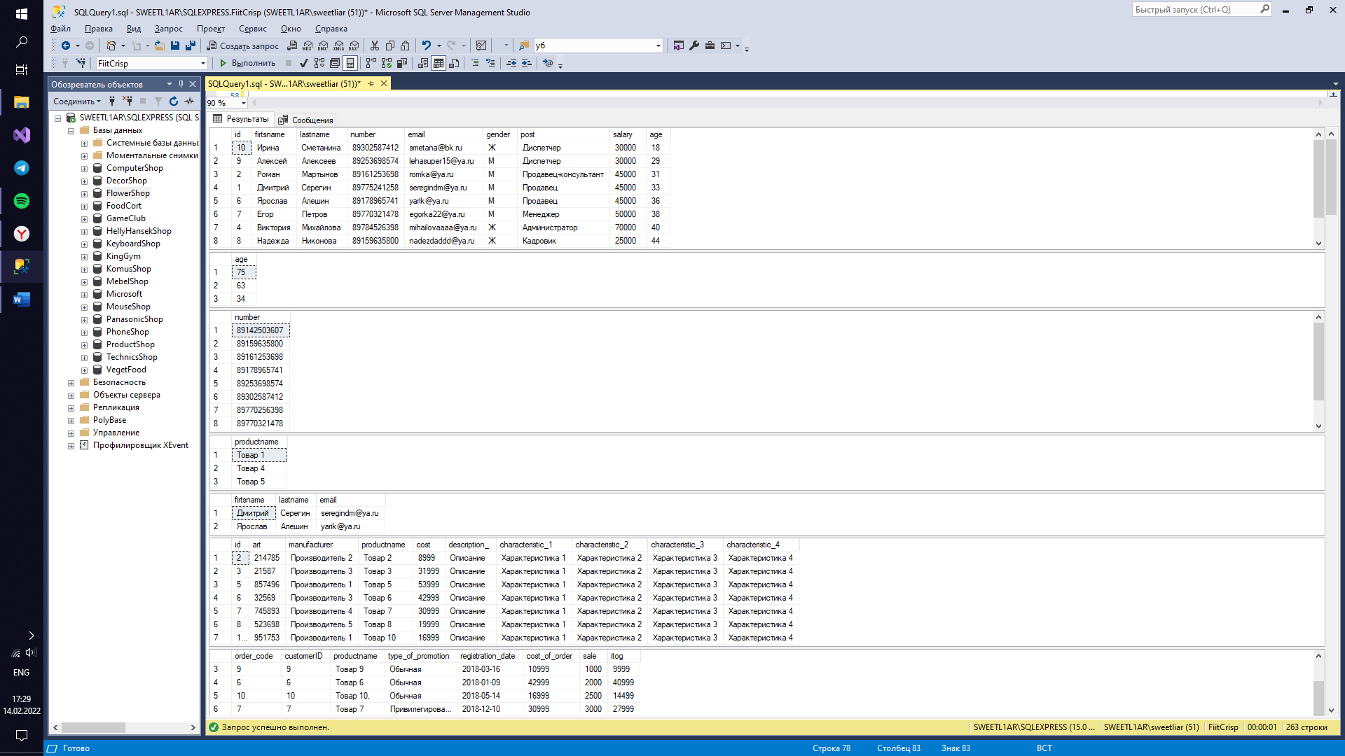

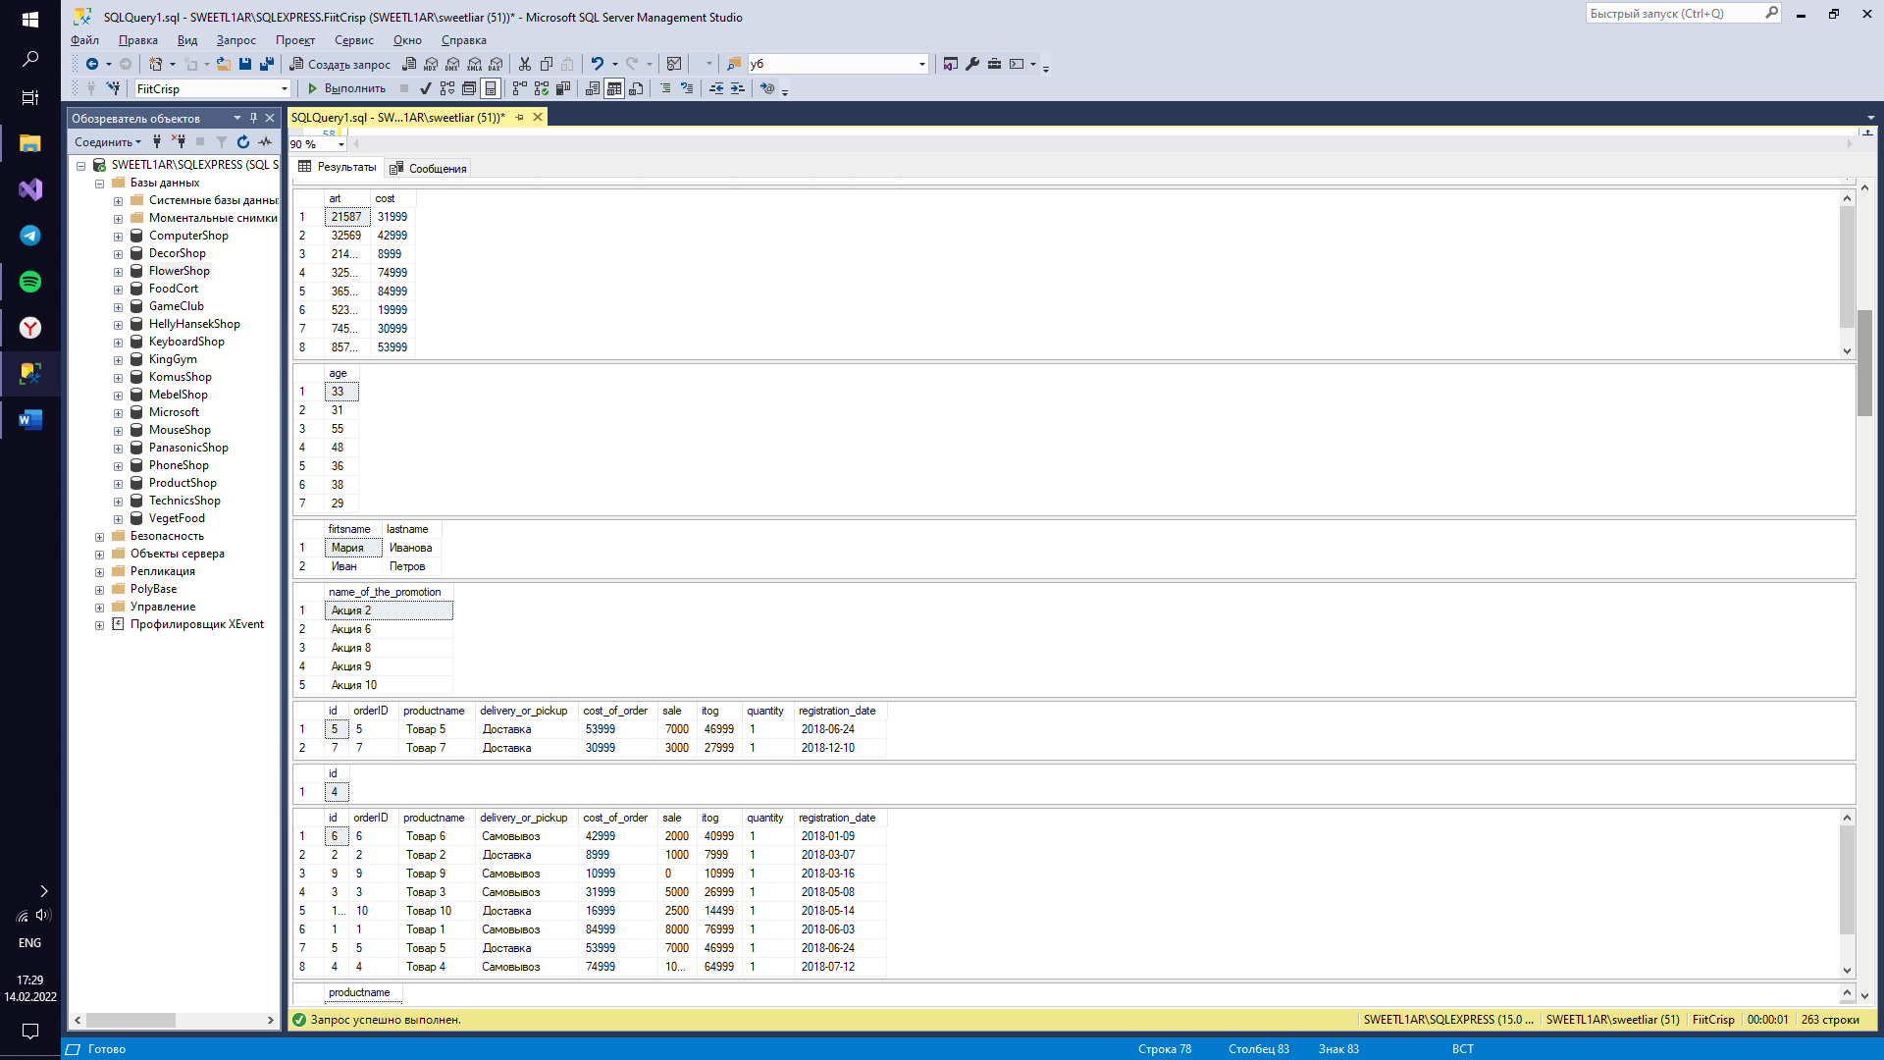

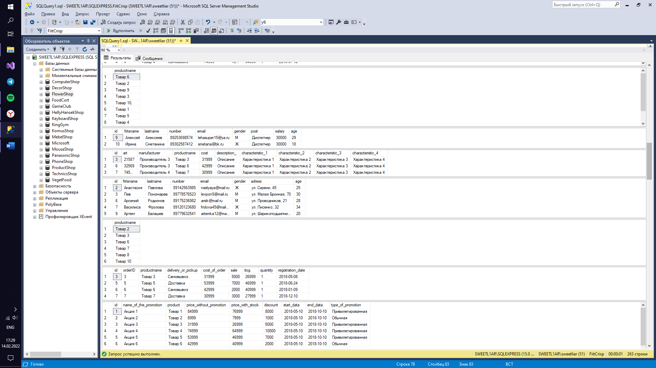

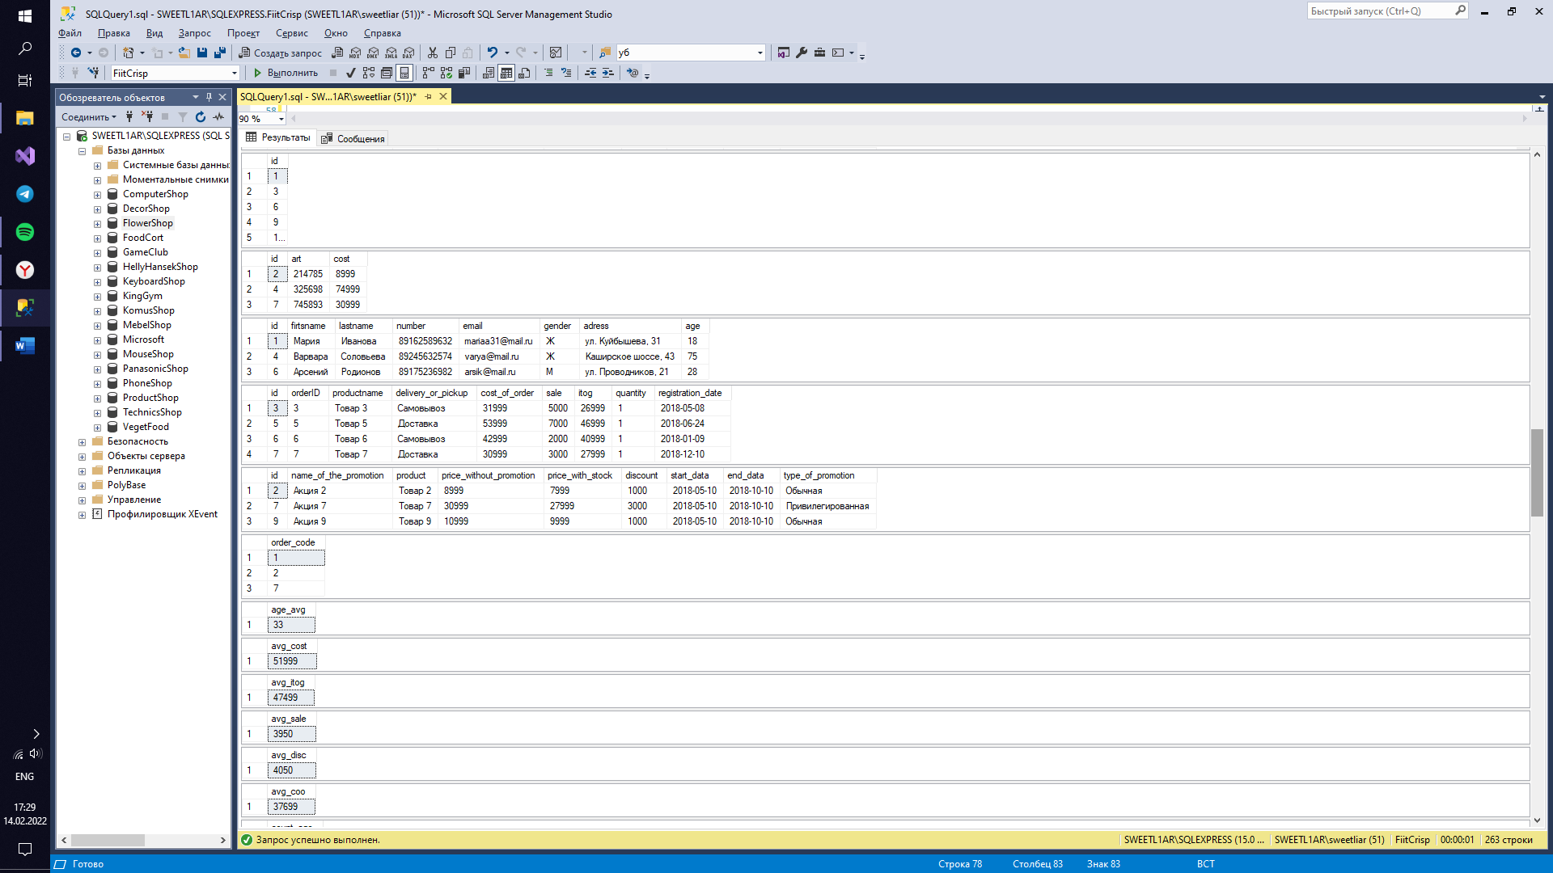

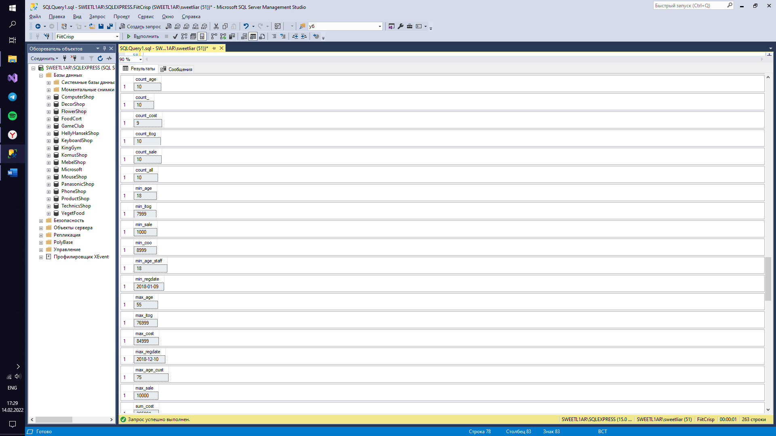

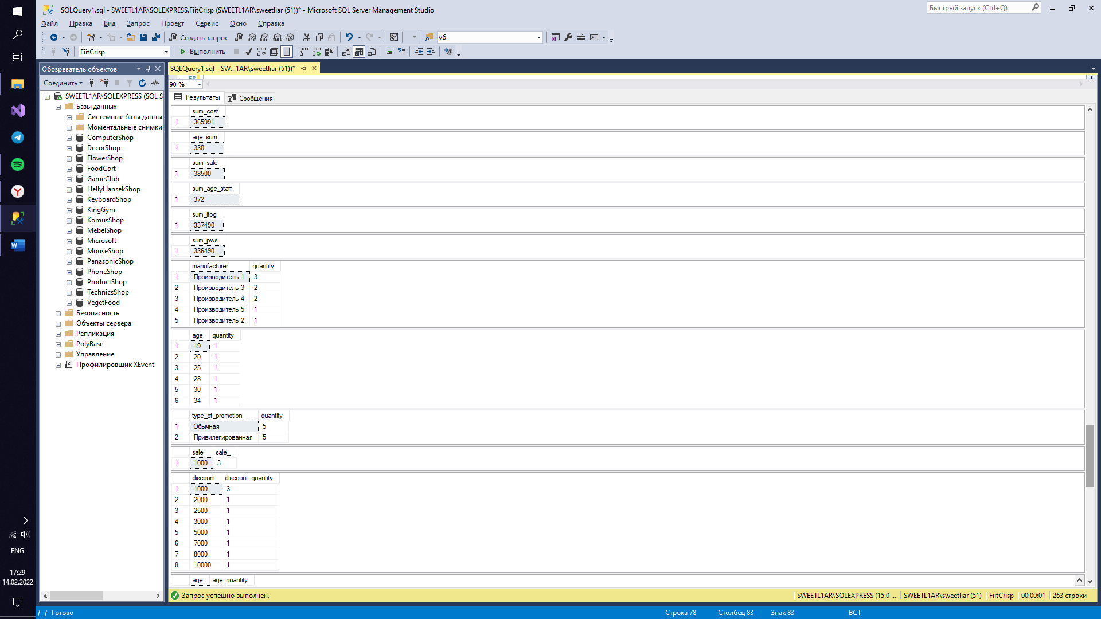

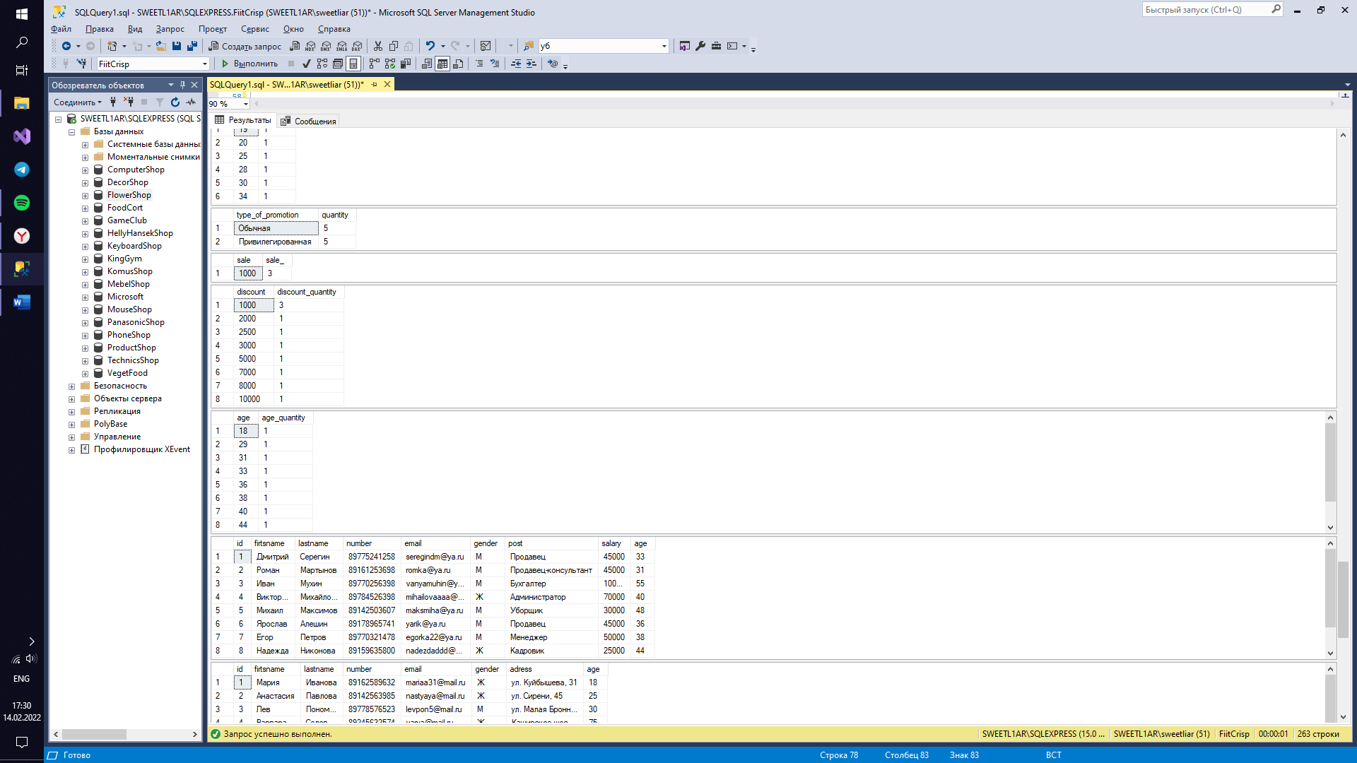

Задание 6.2

create database WaterComp;

go

use WaterComp;

create table staff

(

id int primary key identity,

firtsname nvarchar(50) not null,

lastname nvarchar(50) not null,

number nvarchar(18) unique,

email nvarchar(50) unique,

gender nvarchar(1) check (gender in ('М', 'Ж')),

post nvarchar(50) not null,

salary int not null,

age int

constraint DF_staff_age default 18

constraint CK_staff_age check (Age > 0 and Age < 100)

);

insert into staff(firtsname, lastname, number, email, gender, post, salary, age) values

('Дмитрий', 'Серегин', '89775241258', 'seregindm@ya.ru', 'М', 'Продавец', 45000, 25),

('Роман', 'Мартынов', '89161253698', 'romka@ya.ru', 'М', 'Продавец-консультант', 45000, 23),

('Иван', 'Мухин', '89770256398', 'vanyamuhin@ya.ru', 'М', 'Бухгалтер', 100000, 47),

('Виктория', 'Михайлова', '89784526398', 'mihailovaaaa@ya.ru', 'Ж', 'Администратор', 70000, 32),

('Михаил', 'Максимов', '89142503607', 'maksmiha@ya.ru', 'М', 'Уборщик', 30000, 40),

('Ярослав', 'Алешин', '89178965741', 'yarik@ya.ru', 'М', 'Продавец', 45000, 28),

('Егор', 'Петров', '89770321478', 'egorka22@ya.ru', 'М', 'Менеджер', 50000, 30),

('Надежда', 'Никонова', '89159635800', 'nadezdaddd@ya.ru', 'Ж', 'Кадровик', 25000, 36),

('Алексей', 'Алексеев', '89253698574', 'lehasuper15@ya.ru', 'М', 'Диспетчер', 30000, 21),

('Ирина', 'Сметанина', '89302587412', 'smetana@bk.ru', 'Ж', 'Диспетчер', 30000, default);

create table customer

(

id int primary key identity,

firtsname nvarchar(50) not null,

lastname nvarchar(50) not null,

number nvarchar(18) unique,

email nvarchar(50) unique,

gender nvarchar(1) check (gender in ('М', 'Ж')),

adress nvarchar(90) not null,

age int

constraint DF_customer_age default 18

);

insert into customer(firtsname, lastname, number, email, gender, adress, age) values

('Мария', 'Иванова', '89162589632', 'mariaa31@mail.ru', 'Ж', 'ул. Куйбышева, 31', default),

('Анастасия', 'Павлова', '89142563985', 'nastyaya@mail.ru', 'Ж', 'ул. Сирени, 45', 25),

('Лев', 'Пономарев', '89778576523', 'levpon5@mail.ru', 'М', 'ул. Малая Бронная, 70', 30),

('Варвара', 'Соловьева', '89245632574', 'varya@mail.ru', 'Ж', 'Каширское шоссе, 43', 75),

('Василий', 'Головин', '89289632587', 'vasilyaaa@mail.ru', 'М', 'ул. Маршала Зуева, 12', 63),

('Арсений', 'Родионов', '89175236982', 'arsik@mail.ru', 'М', 'ул. Проводников, 21', 28),

('Василиса', 'Фролова', '89120123680', 'frolova45@mail.ru', 'Ж', 'ул. Лисенко, 32', 34),

('Максим', 'Куликов', '89162574156', 'kulik789@mail.ru', 'М', 'ул. Подводников, 23', 19),

('Артем', 'Балашев', '89779632541', 'artemka12@mail.ru', 'М', 'ул. Шарикоподшипниковская, 3', 20),

('Иван', 'Петров', '89151258745', 'ivan@gamail.com', 'М', 'ул. Ромашки, 56', default);

create table product

(

id int primary key identity(1, 1),

art int unique,

manufacturer nvarchar(100),

productname nvarchar(100) not null,

cost int check (cost > 0) not null,

description_ nvarchar(100) not null,

characteristic_1 nvarchar(50),

characteristic_2 nvarchar(50),

characteristic_3 nvarchar(50),

characteristic_4 nvarchar(50)

);

insert into product(art, manufacturer, productname, cost, description_, characteristic_1, characteristic_2, characteristic_3, characteristic_4) values

(365228, 'Производитель 1', 'Товар 1', 84999, 'Описание', 'Характеристика 1', 'Характеристика 2', 'Характеристика 3', 'Характеристика 4'),

(214785, 'Производитель 2', 'Товар 2', 8999, 'Описание', 'Характеристика 1', 'Характеристика 2', 'Характеристика 3', 'Характеристика 4'),

(021587, 'Производитель 3', 'Товар 3', 31999, 'Описание', 'Характеристика 1', 'Характеристика 2', 'Характеристика 3', 'Характеристика 4'),

(325698, 'Производитель 4', 'Товар 4', 74999, 'Описание', 'Характеристика 1', 'Характеристика 2', 'Характеристика 3', 'Характеристика 4'),

(857496, 'Производитель 1', 'Товар 5', 53999, 'Описание', 'Характеристика 1', 'Характеристика 2', 'Характеристика 3', 'Характеристика 4'),

(032569, 'Производитель 3', 'Товар 6', 42999, 'Описание', 'Характеристика 1', 'Характеристика 2', 'Характеристика 3', 'Характеристика 4'),

(745893, 'Производитель 4', 'Товар 7', 30999, 'Описание', 'Характеристика 1', 'Характеристика 2', 'Характеристика 3', 'Характеристика 4'),

(523698, 'Производитель 5', 'Товар 8', 19999, 'Описание', 'Характеристика 1', 'Характеристика 2', 'Характеристика 3', 'Характеристика 4'),

(452178, 'Производитель 6', 'Товар 9', 10999, 'Описание', 'Характеристика 1', 'Характеристика 2', 'Характеристика 3', 'Характеристика 4'),

(951753, 'Производитель 1', 'Товар 10', 16999, 'Описание', 'Характеристика 1', 'Характеристика 2', 'Характеристика 3', 'Характеристика 4');

create table cart

(

order_code int primary key identity(1, 1),

customerID int references customer (id),

productname nvarchar(100),

type_of_promotion nvarchar(50) check (type_of_promotion in ('Обычная', 'Привилегированная')),

registration_date date not null,

cost_of_order int check (cost_of_order > 0) not null,

sale int,

itog int

);

insert into cart(customerID, productname, type_of_promotion, registration_date, cost_of_order, sale, itog) values

(1, 'Товар 1', 'Привилегированная', '2018-06-03', 84999, 8000, 76999),

(2, 'Товар 2', 'Обычная', '2018-03-07', 8999, 1000, 7999),

(3, 'Товар 3', 'Привилегированная', '2018-05-08', 31999, 5000, 26999),

(4, 'Товар 4', 'Привилегированная', '2018-07-12', 74999, 10000, 64999),

(5, 'Товар 5', 'Привилегированная', '2018-06-24', 53999, 7000, 46999),

(6, 'Товар 6', 'Обычная', '2018-01-09', 42999, 2000, 40999),

(7, 'Товар 7', 'Привилегированная', '2018-12-10', 30999, 3000, 27999),

(8, 'Товар 8', 'Обычная', '2018-09-29', 19999, 1000, 18999),

(9, 'Товар 9', 'Обычная', '2018-03-16', 10999, 1000, 9999),

(10, 'Товар 10,', 'Обычная', '2018-05-14', 16999, 2500, 14499);

create table orders

(

id int primary key identity,

orderID int references cart (order_code),

productname nvarchar(200),

delivery_or_pickup nvarchar(70) check (delivery_or_pickup in ('Самовывоз', 'Доставка'))not null,

cost_of_order int check (cost_of_order > 0) not null,

sale int,

itog int,

quantity int check (quantity > 0),

registration_date date not null,

);

insert into orders(orderID, productname, delivery_or_pickup, cost_of_order, sale, itog, quantity, registration_date) values

(1, 'Товар 1', 'Самовывоз', 84999, 8000, 76999, 1, '2018-06-03'),

(2, 'Товар 2', 'Доставка', 8999, 1000, 7999, 1, '2018-03-07'),

(3, 'Товар 3', 'Самовывоз', 31999, 5000, 26999, 1, '2018-05-08'),

(4, 'Товар 4', 'Самовывоз', 74999, 10000, 64999, 1, '2018-07-12'),

(5, 'Товар 5', 'Доставка', 53999, 7000, 46999, 1, '2018-06-24'),

(6, 'Товар 6', 'Самовывоз', 42999, 2000, 40999, 1, '2018-01-09'),

(7, 'Товар 7', 'Доставка', 30999, 3000, 27999, 1, '2018-12-10'),

(8, 'Товар 8', 'Доставка', 19999, 1000, 18999, 1, '2018-09-29'),

(9, 'Товар 9', 'Самовывоз', 10999, 0, 10999, 1, '2018-03-16'),

(10, 'Товар 10', 'Доставка', 16999, 2500, 14499, 1, '2018-05-14');

create table stock

(

id int primary key identity,

name_of_the_promotion nvarchar(50),

product nvarchar(50) not null,

price_without_promotion int not null,

price_with_stock int not null,

discount int check (discount > 0),

start_data date,

end_data date,

type_of_promotion nvarchar(50) check (type_of_promotion in ('Обычная', 'Привилегированная'))

);

insert into stock(name_of_the_promotion, product, price_without_promotion, discount, price_with_stock, start_data, end_data, type_of_promotion) values

('Акция 1', 'Товар 1', 84999, 8000, 76999, '2018-08-10', '2018-10-10', 'Привилегированная'),

('Акция 2', 'Товар 2', 8999, 1000, 7999, '2018-05-10', '2018-10-10', 'Обычная'),

('Акция 3', 'Товар 3', 31999, 5000, 26999, '2018-05-10', '2018-10-10', 'Привилегированная'),

('Акция 4', 'Товар 4', 74999, 10000, 64999, '2018-05-10', '2018-08-10', 'Привилегированная'),

('Акция 5', 'Товар 5', 53999, 7000, 46999, '2018-05-10', '2018-11-10', 'Привилегированная'),

('Акция 6', 'Товар 6', 42999, 2000, 40999, '2018-07-10', '2018-11-10', 'Обычная'),

('Акция 7', 'Товар 7', 30999, 3000, 27999, '2018-06-10', '2018-10-10', 'Привилегированная'),

('Акция 8', 'Товар 8', 19999, 1000, 18999, '2018-05-10', '2018-12-10', 'Обычная'),

('Акция 9', 'Товар 9', 10999, 1000, 9999, '2018-03-10', '2018-12-10', 'Обычная'),

('Акция 10', 'Товар 10', 16999, 2500, 14499, '2018-05-10', '2018-09-10', 'Обычная');

select * from staff;

select * from customer;

select * from product;

select * from cart;

select * from stock;

select * from orders;

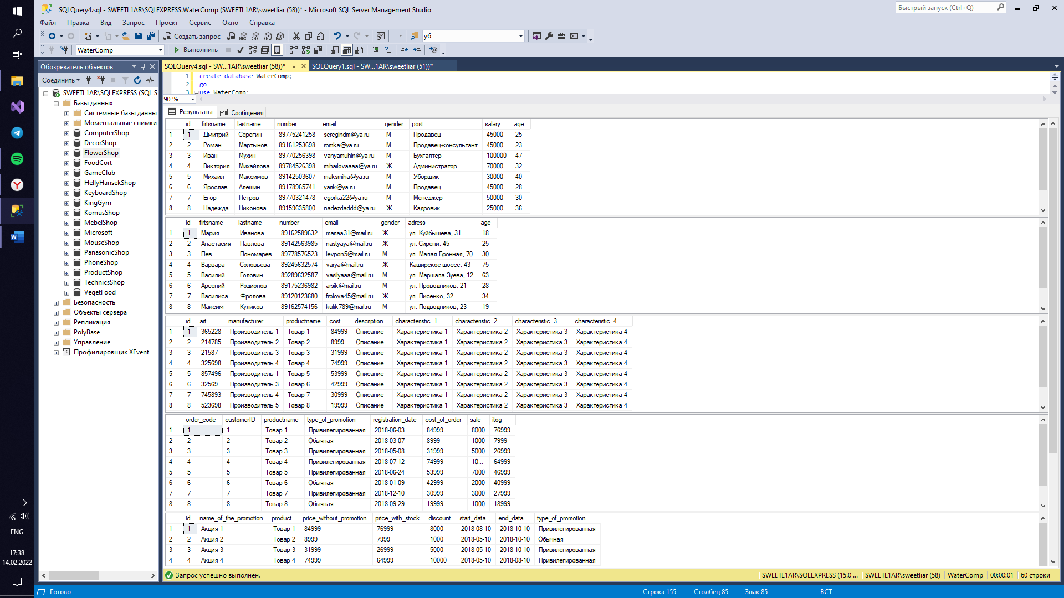

use WaterComp;

update customer set age = age + 10 where age > 40;

delete stock where name_of_the_promotion = 'Акция 2';

select * from staff order by post;

select age from staff where age > 25;

select email from customer;

select * from cart where sale > 5000;

select firtsname, lastname, email from staff where post = 'Администратор' or age > 20;

select * from stock where name_of_the_promotion = 'Акция 3' or discount < 2000;

select * from orders order by itog;

select art, cost, description_ from product order by id;

select age, post from staff where gender = 'Ж';

select firtsname, lastname from customer where age = 30;

select * from orders where delivery_or_pickup = 'Самовывоз' and cost_of_order > 20000;

select id, product from stock where discount = 5000;

select * from orders order by registration_date;

select productname from cart order by registration_date;

select name_of_the_promotion from stock where type_of_promotion = 'Привилегированная';

select * from staff where age between 18 and 30;

select * from product where cost between 20000 and 50000;

select * from customer where age between 18 and 40;

select productname from orders where sale between 2000 and 3000;

select * from orders where cost_of_order between 10000 and 50000;

select * from stock where discount between 0 and 35000;

select id from customer where age in (18, 20, 22);

select id, art, cost from product where manufacturer in ('Производитель 4', 'Производитель 2');

select * from customer where email in ('mariaa31@mail.ru', 'ivan@gamail.com');

select * from orders where sale in (2000, 3000, 5000, 7000);

select * from stock where name_of_the_promotion in ('Акция 1', 'Акция 3', 'Акция 8');

select order_code from cart where itog in (40999, 64999);

select avg(age) as age_avg from staff;

select avg(cost) as avg_cost from product where manufacturer = 'Производитель 1';

select avg(itog) as avg_itog from cart where cost_of_order > 20000;

select avg(sale) as avg_sale from orders;

select avg(discount) as avg_disc from stock;

select avg(cost_of_order) as avg_coo from cart;

select count(*) as count_ from cart;

select count(cost) as count_cost from product;

select count(age) as count_age from customer;

select count(itog) as count_itog from cart;

select count(*) as count_sale from cart;

select count(*) as count_all from orders;

select min(age) as min_age from customer;

select min(itog) as min_itog from cart;

select min(sale) as min_sale from cart;

select min(cost_of_order) as min_coo from orders;

select min(distinct age) as min_age_staff from staff;

select min(start_data) as min_data from stock;

select max(age) as max_age from staff;

select max(itog) as max_itog from cart;

select max(distinct cost) as max_cost from product;

select max(end_data) as max_data from stock;

select max(age) as max_age_cust from customer;

select max(sale) as max_sale from cart;

select sum(cost) as sum_cost from product;

select sum(age) as age_sum from customer;

select sum(distinct sale) as sum_sale from cart;

select sum(age) as sum_age_staff from staff;

select sum(itog) as sum_itog from orders;

select sum(price_without_promotion) as sum_pws from stock;

select manufacturer, count(*) as quantity from product group by manufacturer order by quantity;

select age, count(*) as quantity from customer where age > 20 group by age;

select type_of_promotion, count(*) as quantity from cart group by type_of_promotion having count(*) > 1;

select sale, count(*) as sale_ from cart group by sale having count(*) >= 1;

select discount, count(*) as discount_quantity from stock group by discount order by discount;

select age, count(*) as age_quantity from staff group by age having count(*) > 1;

select * from staff;

select * from customer;

select * from product;

select * from cart;

select * from stock;

select * from orders;

